FINAL PROJECT

BS SOFTWARE ENGINEERING

6th SEMESTER

**NOOR UL HUDA 20-NTU-CS-1133**

**ABDULLAH TABASSUM 20-NTU-CS-1140**

**ALEESHA RUSTAM 20-NTU-CS-1094**



**SUBMITTED TO : SIR MUHAMMAD NAEEM**

**DATE : 07-06-2023**

***------------------------------------------------------***

***MEDICAL STORE MANAGEMENT SYSTEM***

GENERAL MODEL FOR SOFTWARE REENGINEERING:

We are using this model for medical store management system which include three principles:

1. **Principle of Abstraction**
2. **Principle of Alternation**
3. **Principle of Refinement**

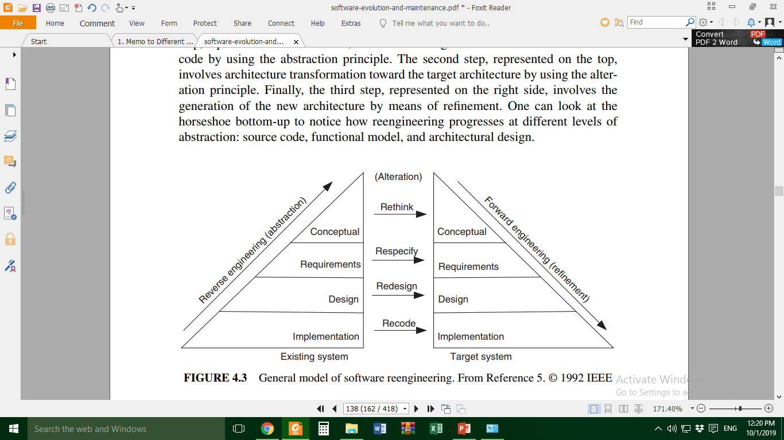

**IMPLEMENTATION**

The code is done on Dev C++ on version 5.11 using C++ language. It is using the file management system to store the all record.The libraries used for this code are:

1. Iostream
2. Fstream
3. Cstring
4. Iomanip
5. cstdlib

The implementation of code is present in Legacy folder with name “Medical_Store_System”.

**DESIGN**

# **USE CASE DIAGRAM:**

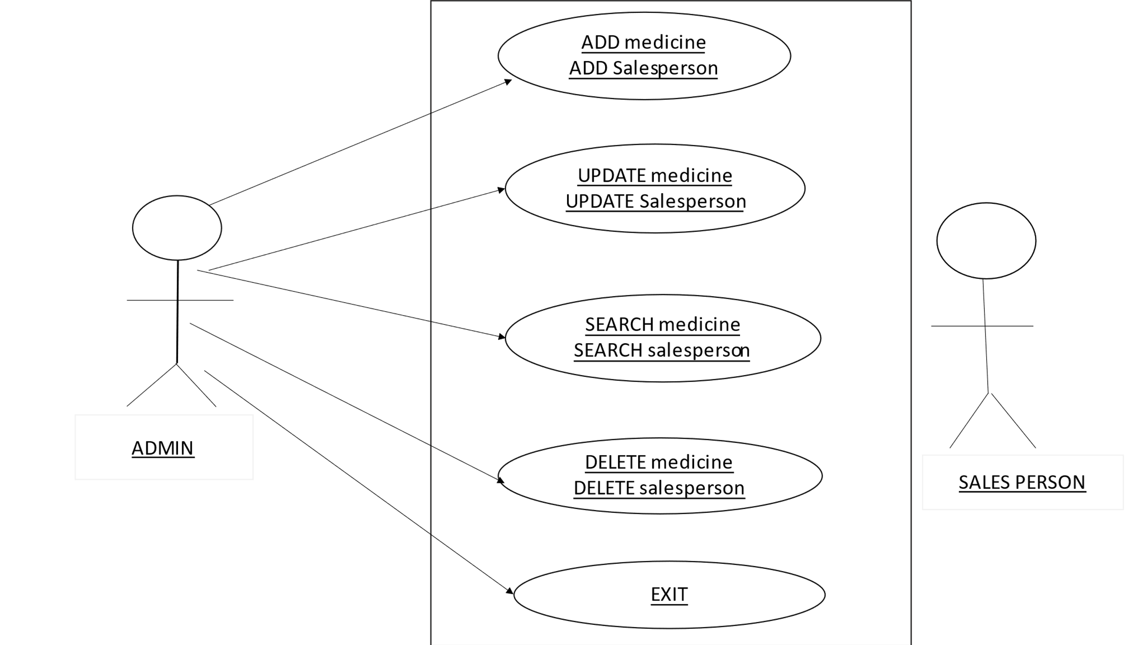

# **MODULES**

There are three in modules in legacy system:

1. Medicine

2. Sale Medicine

3. Sale Person

FUNCTION

The programming language that will be used in coding this work is C++ programming language, which can be developed modules of program running, firstly the introduction of the program is displayed and then the main menu which is made up of:

ADD:

This allows you to enter the information of new Medicine and Salesperson.

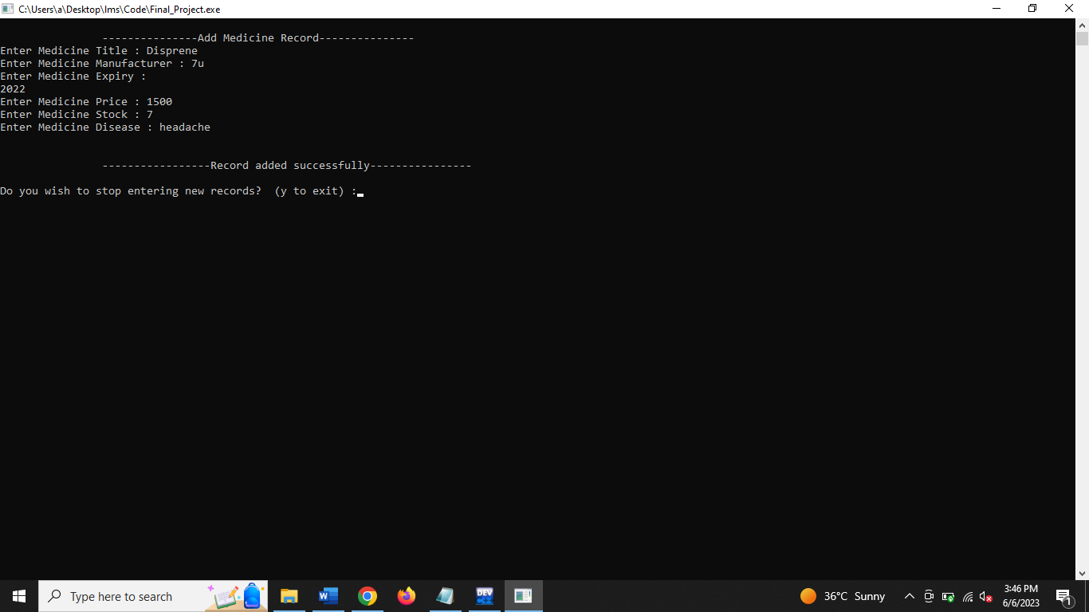

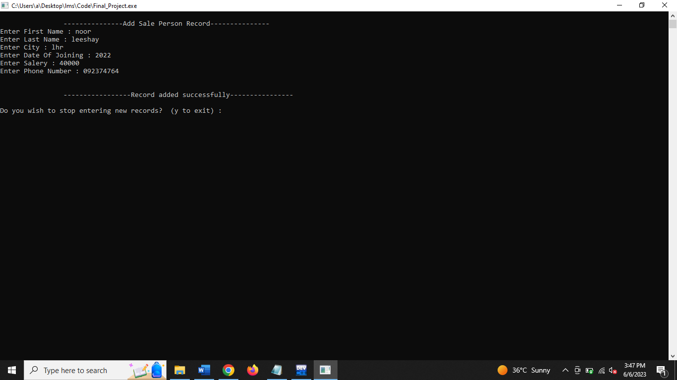

UPDATE:

This allow you to edit some information of Medicine and Salesperson whose want change something in his record.

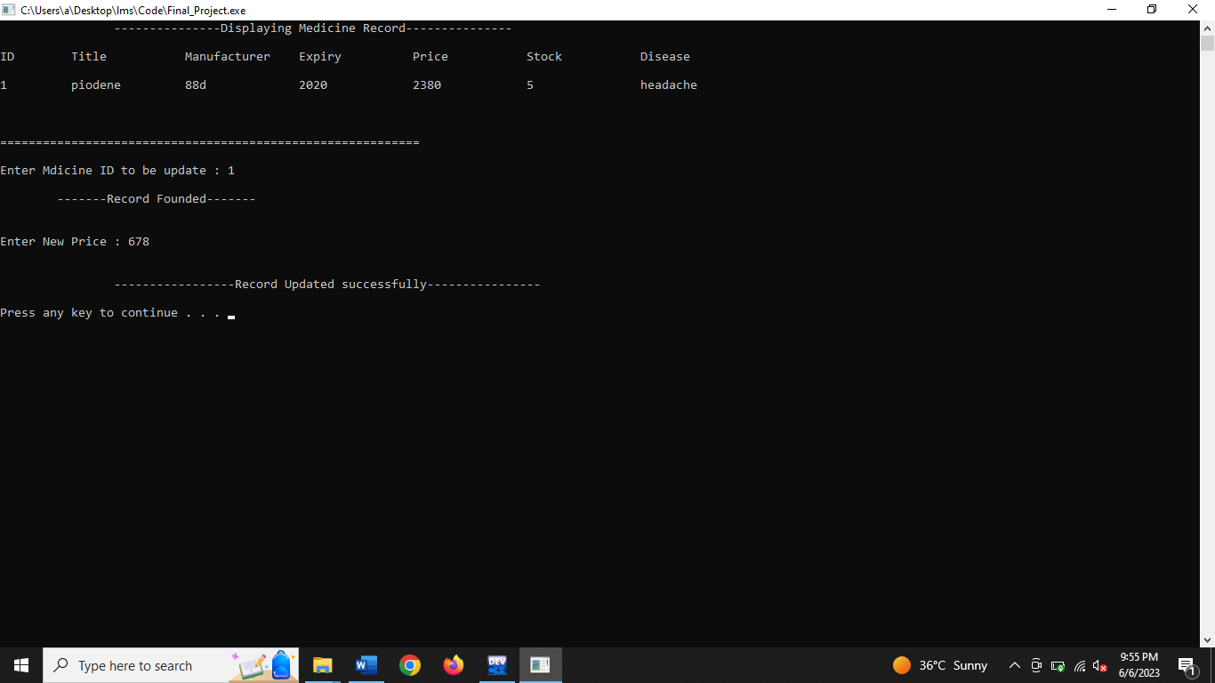

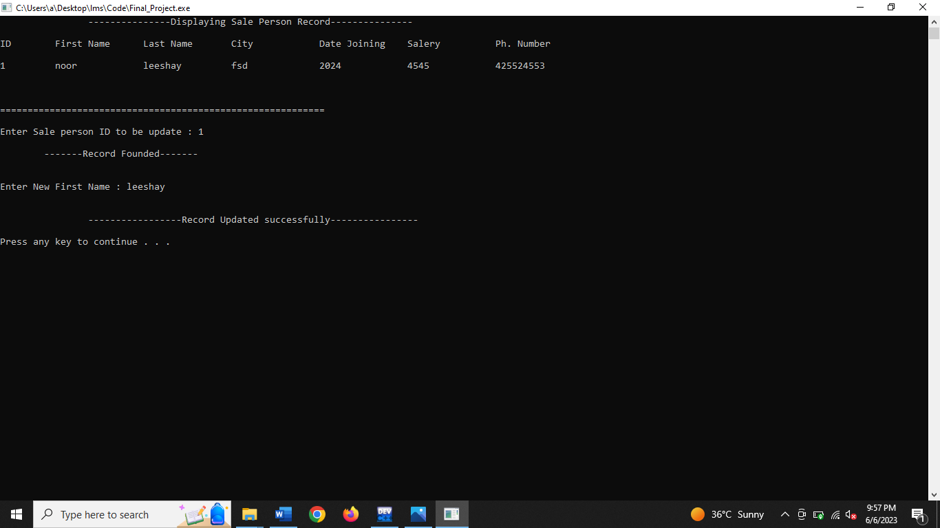

DISPLAY:

This allow you to display all the record of Medicine and Salesperson.

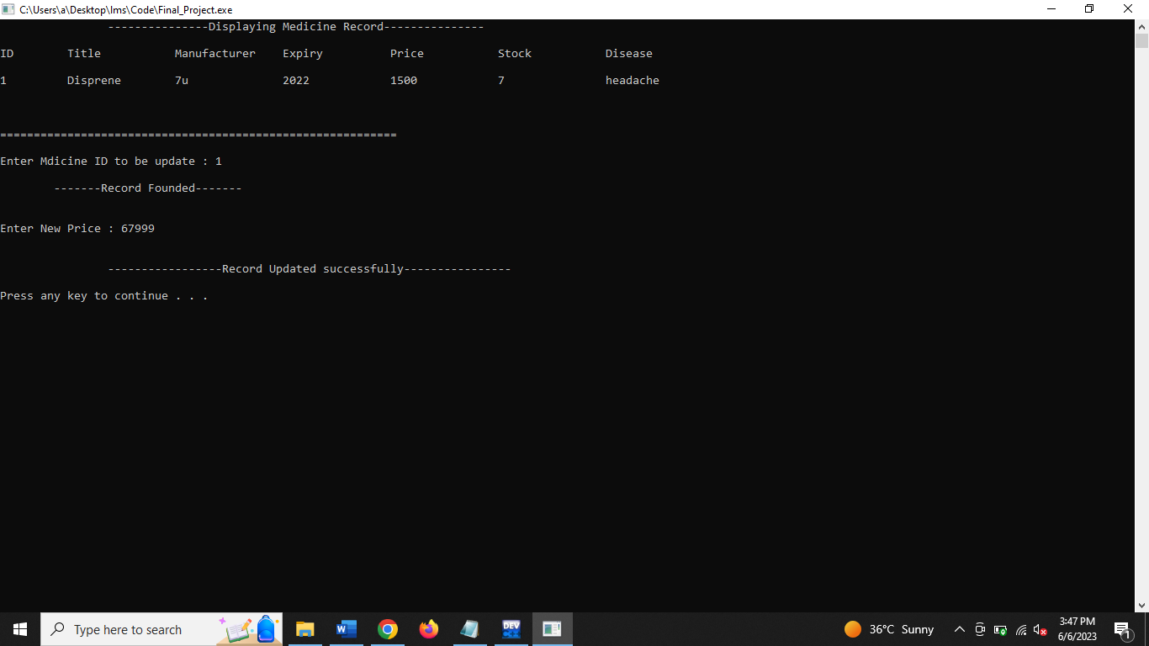

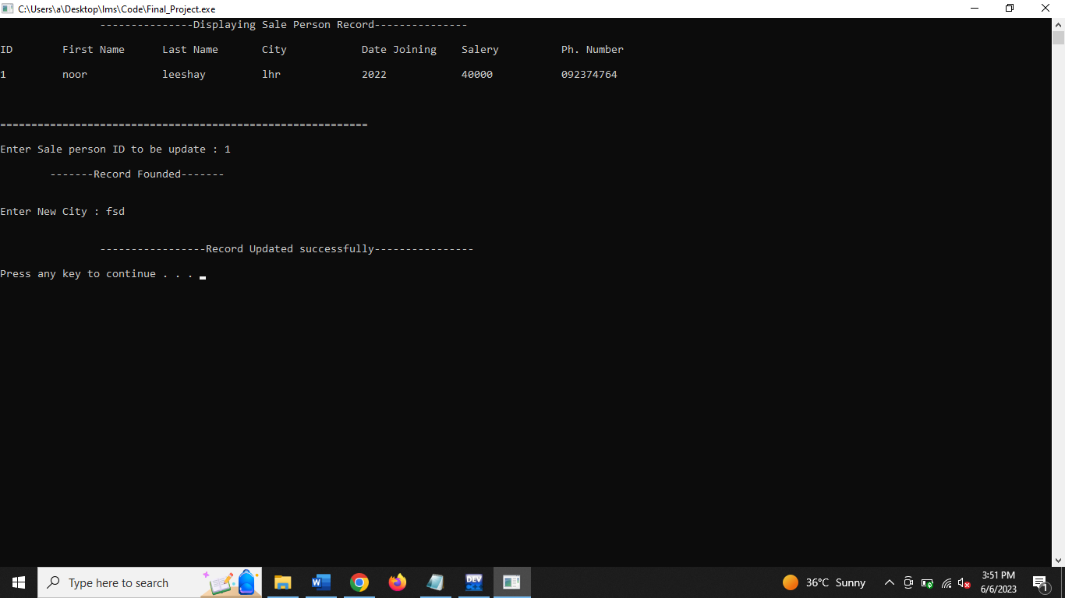

SEARCH:

This allow you to search a Medicine and Salesperson, and for the reference if they want to view a detail of the Medicine or Salesperson.

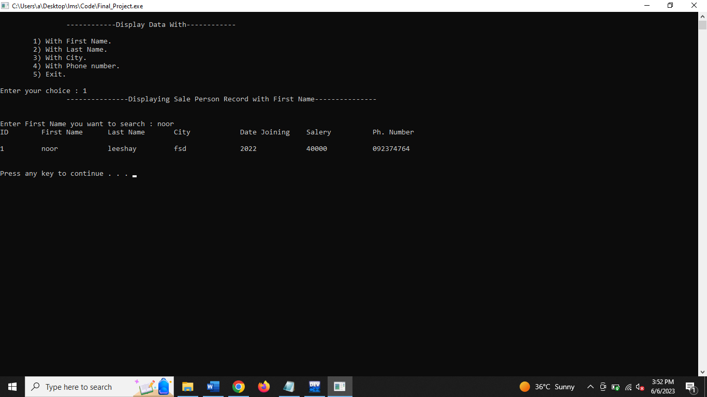

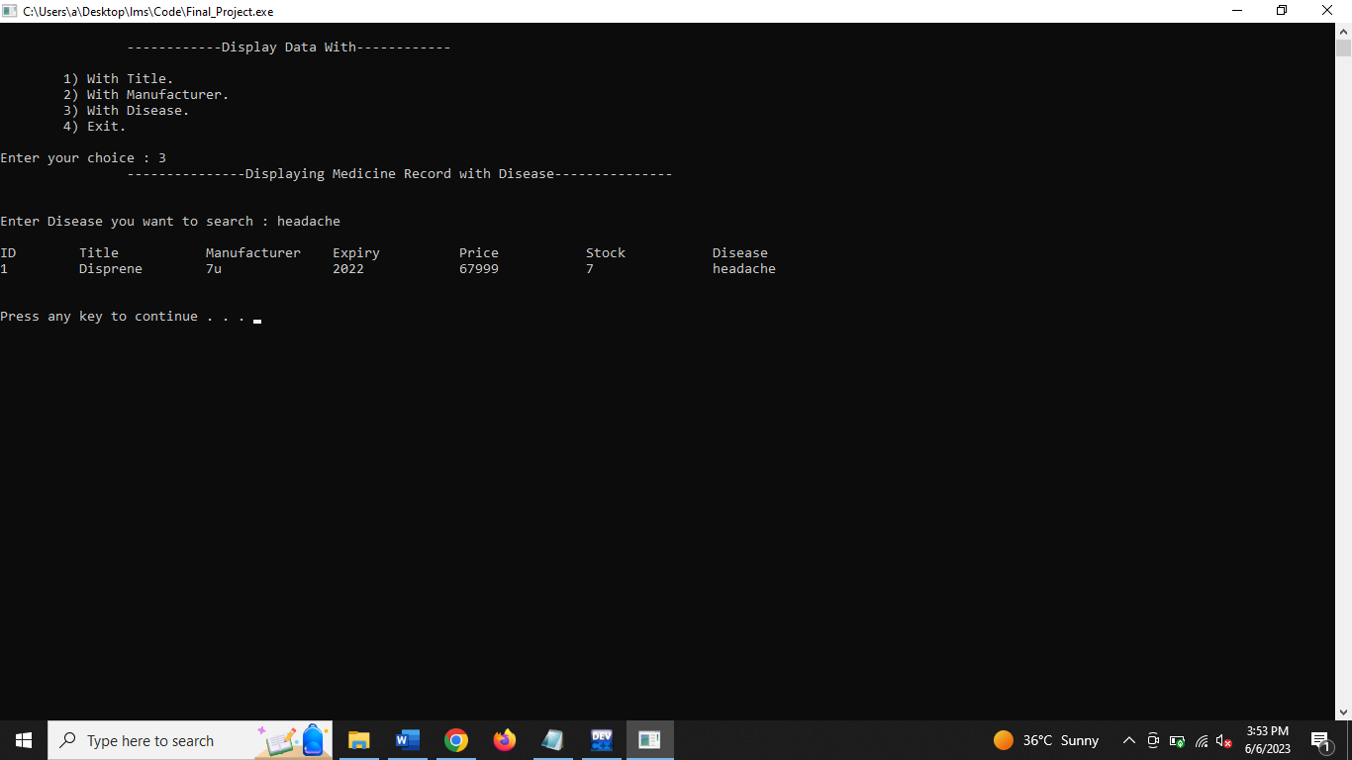

DELETE:

This allow you to delete to a record of the Medicine and Salesperson when needed.

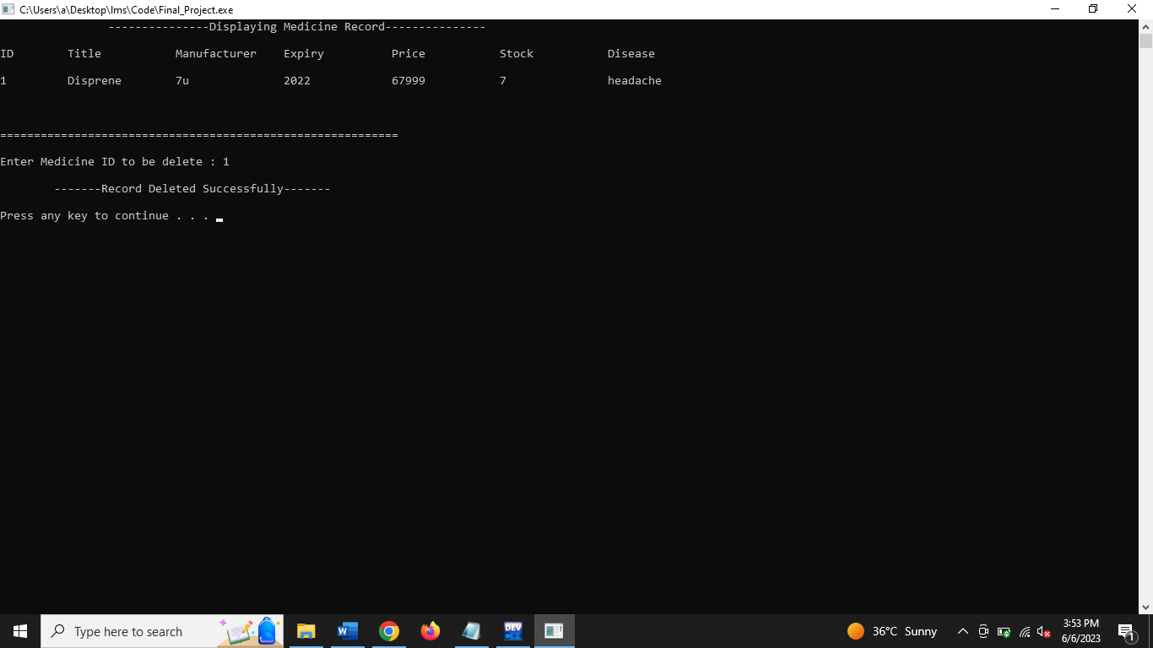

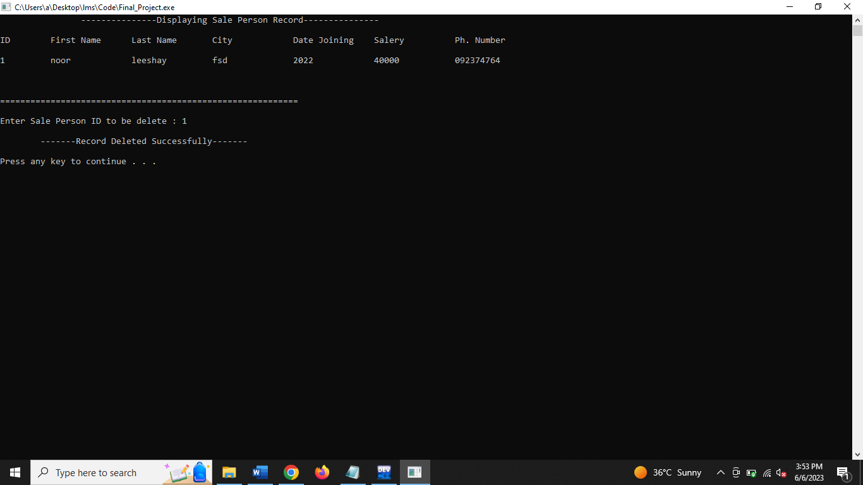

EXIT:

If the user wants to go for break or is a closing time for the day, this module will allow the user to quit from the system and close.

**REQUIREMENTS**

We have three modules in it which can perform the following functions:

1. **MEDICINE**

It has the following functions:

1. **Add Medicine Record.**

When we select this option it will do following steps:

i. Ask do you want to enter new records by removing previous?

**ii**. By giving ‘y’ in input it will ask us the information about the medicine which includes medicine title, manufacturer, expiry date, price, stock and what medicine is use for.

**iii**. After entering records it will ask if we want to further add more records or not. By entering ‘y’ it will exit.

1. **Display Medicine Record.**

By selecting this option it will simply show us the record of medicine we have in stock.

1. **Display Medicine Record with related data.**

By selecting this option we have these following steps:

1) With Title.

2) With Manufacturer.

3) With Disease.

4) Exit.

We can search medicine with title, manufacturer and specific disease name that medicine can cure.

**4) Update Medicine Record.**

By selecting this option we have these following steps:

1) Update Title.

2) Update Manufacturer.

3) Update Price.

4) Update Expiry.

5) Update Stock.

6) Exit.

We can update medicine record by updating title, manufacturer, price, expiry, stock, and at last we exit after performing update function.

**5) Delete Medicine Record**.

By selecting this option

The system will ask about the ID which we want to delete.

1. **SALESPERSON**

It has the following functions:

1. **Add Sale Person Record.**

When we select this option it will do following steps:

i. Ask do you want to enter new records by removing previous?

**ii**. By giving ‘y’ in input it will ask us the information about the salesperson which includes salesman first name, Last name, city, Date of joining , salary and phone number.

**iii**. After entering records it will ask if we want to further add more records or not. By entering ‘y’ it will exit.

1. **Display Sale Person Record.**

By selecting this option it will simply show us the record of medicine we have in stock.

1. **Display Sale Person Record with related data.**

By selecting this option, we have these following steps:

1) With First Name.

2) With Last Name.

3) With City.

4) With Phone number.

5) Exit.

We can search sales person record by first name, Last name, city, phone number.

1. **Update Sale Person Record.**

By selecting this option we have these following steps:

1) Update First Name.

2) Update Last Name.

3) Update City.

4) Update Phone Number.

5) Update Salary.

6) Exit.

We can update salesperson record by updating the first name, last name, city, phone number, salary.

1. **Delete Sale Person Record.**

By selecting this option, the system will ask about the salesperson ID which we want to delete.

1. **SALE MEDICINE**

It has the following functions:

1. **Sale New Medicine.**

When we click this option the system will ask “Enter ID of Medicine you want to Sell” after this system will ask about the medicine stock if stock is available then show message “Medicine sell successfully”.

1. **Exit**

We can exit from the system.

**CONCEPTUAL LEVEL**

The system will enable the medical store staff to defeat the inconveniences faced by the Medical Store. The system program is created on C++, which is a programming language. In the system, there is also a requirement for the storage space of salesperson id, salesperson name, salesperson city, salesperson phone number. This program will also allow the user to add record, search record, display record and delete record of salesperson. Since people now a day does not want to spend much of their time in every aspect of duty. Also the staff’s members will find it easy to consult people in easier way instead of them to be giving whatever receipt or registering people manually this system will make them to do their work in a simple and cleared way which will make their work accurately.

**TARGET SYSTEM**

## **CONCEPTUAL LEVEL:**

Hospital management system will help the staff at the medical store overcome the difficulties they encounter. It not only stores the data of medicine but also the data of patient to whom medicine is prescribed and record of doctor who prescribed it. The system program is created on Visual Studio with C#, which is a programming language. This program will also allow the user to add record, update, search record, display record and delete record. It will maintain the data of patient, doctor, pharmacy and admin, so that system will not be access by unauthorized person. The patient can also get appointments from the doctor which will be suggest to them according to their disease.

This new system will keep detailed records and make it easier for people to visit the store. The staff will also find it easier to assist people, without needing to give out receipts or register them manually. The system will simplify their work, leading to more accurate and efficient performance.

# **REQUIREMENTS**

When system starts first form display is of portal in which there are four modules (Admin, Doctor, Patient, Pharmacy) and one exit option.

1. **Admin:**

* The first module is related to Admin:
* **Login:** Admin is only person who can login in system through username and password. All the data will be managed by him. Not any person other than him access the data.
* He can display and add the patient record and show his information to him.
* Admin can search the patients record by his/her CNIC.
* Admin can update the patient record by requiring CNIC, name, Address, age, gender, Phone number.

1. **Doctor:**

* Doctor give prescription to patients related to medicines.
* Doctor detail add in hospital by adding Doctor CNIC, ID, Name, Address, Department, Qualification, and cell number.

1. **Patient:**

* Patient can add data of himself by adding name, age, address, phone number, gender, CNIC, department, doctor related to his/her disease, Time and date.
* Patient also take appointment from doctor by adding appointment number, Date, Time, Patient CNIC.

1. **Pharmacy:**

* Pharmacy add record of prescription by adding patient CNIC, medicine name, medicine code, medicine dosage.

1. **Exit:**

* We can exit from the system.

**DESIGN**

We use the 3 Tier architecture in our project. A three-tier architecture consists of three layers: presentation, business, and data. The presentation layer handles user interface, the application layer processes logic, and the data layer manages storage. It provides scalability, modularity, and separation of concerns for building robust and maintainable systems. First, we make BAL layer this is business access layer in which we make our all classes. 2nd layer id DAL this data access layer in which we handle our database connections and 3rd layer is PAL this presentation layer in which we make our all forms related to our modules.

**CLASS DIAGRAM:**

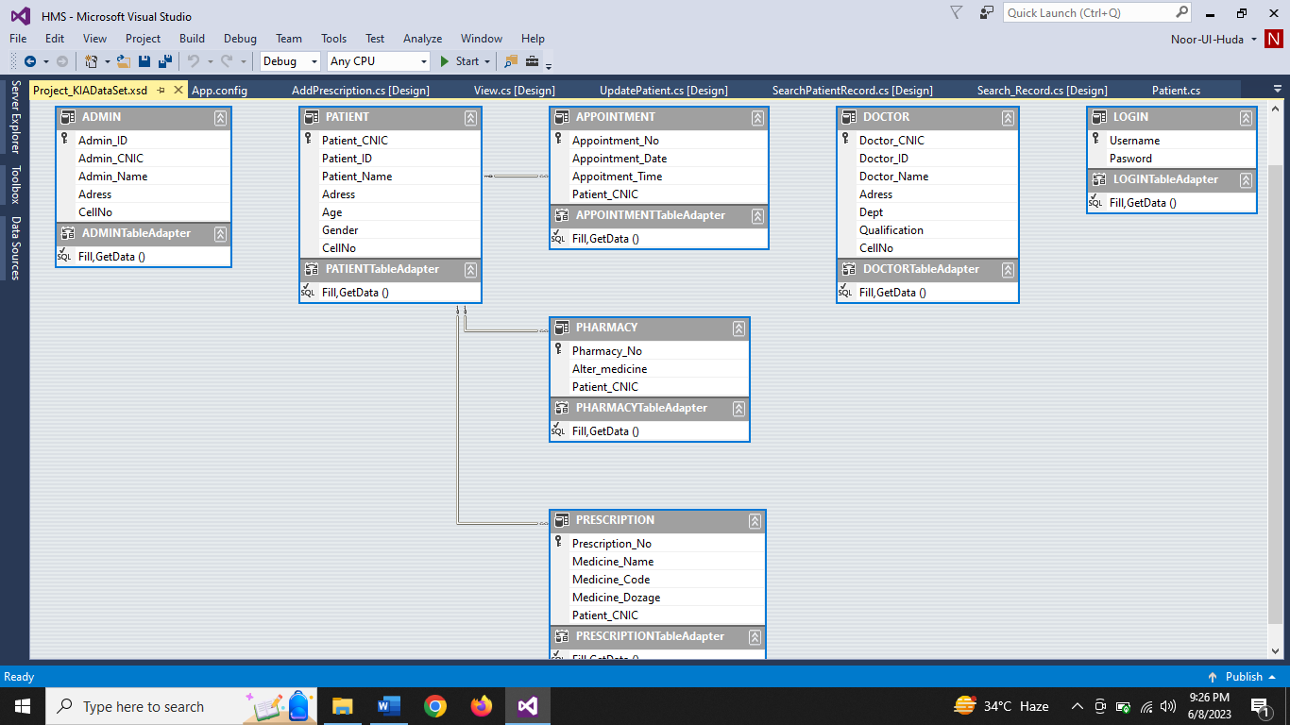

**MODULES:**

There are total 4 modules in this updated system .

**1 )** Admin

**2 )**  Patient

**3 )** Doctor

**4 )** Pharmacy

**ADD RECORD:**

In this patient can add his record.

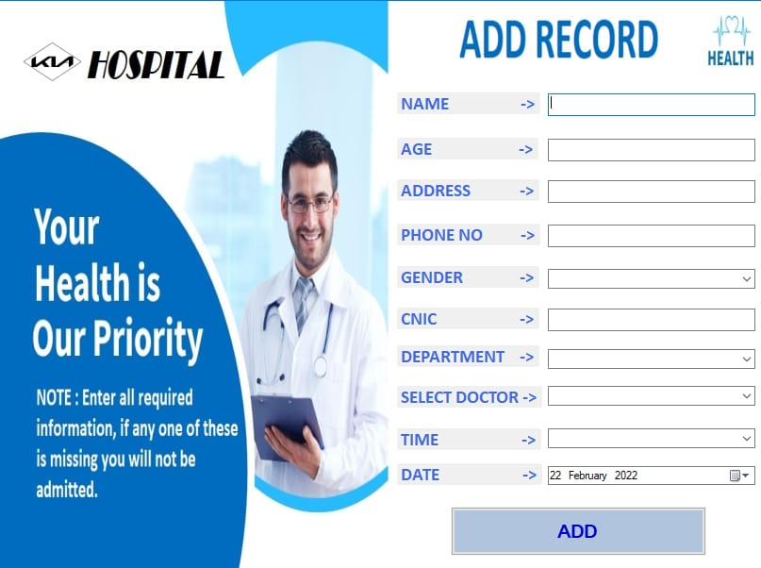

**PATIENT RECORD:**

In this admin can add, search, update, display the patient record.

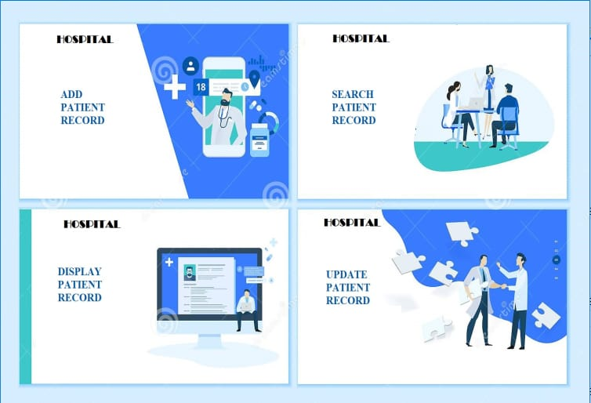

**PRESCRIPTION RECORD:**

In this we can add prescription of patient.

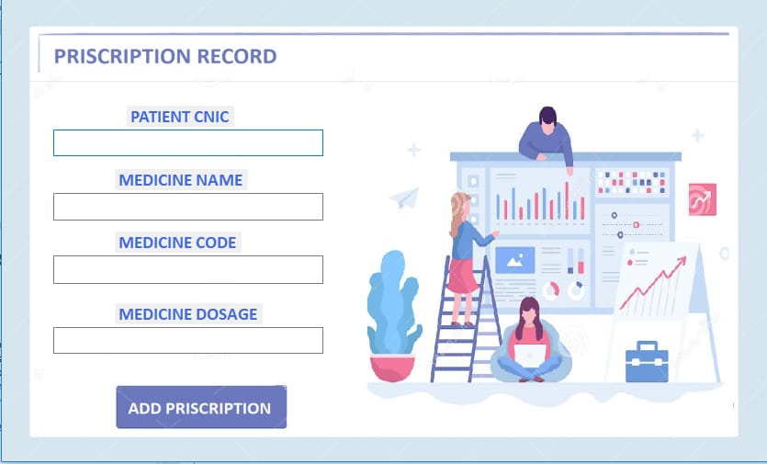

**SEARCH RECORD:**

In this we can search record of patient .

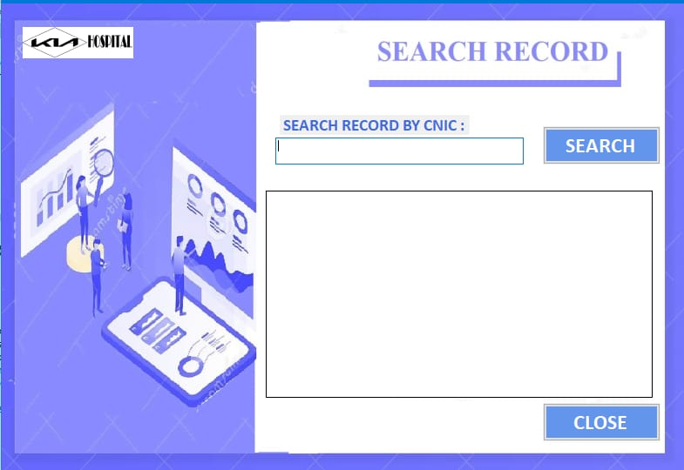

**SIGN IN:**

In this we can sign in the new patient.

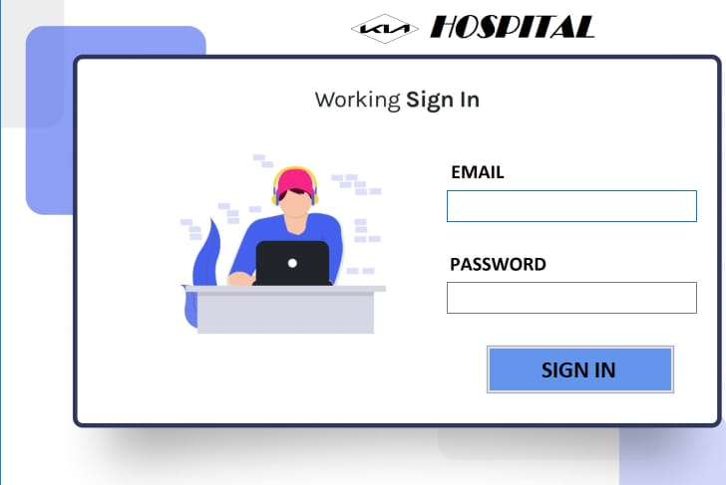

**PATIENT RECORD:**

In this we can check patient record in hospital.

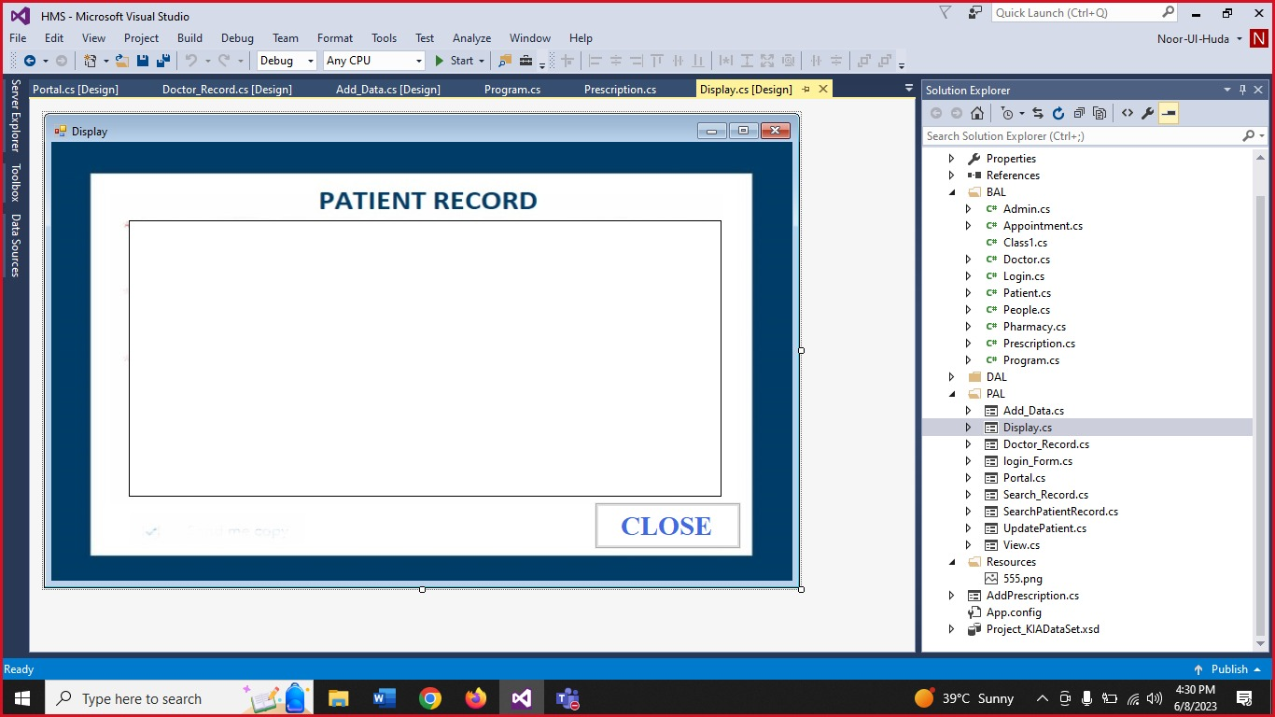

## **UPDATE RECORD:**

We can update patient records.

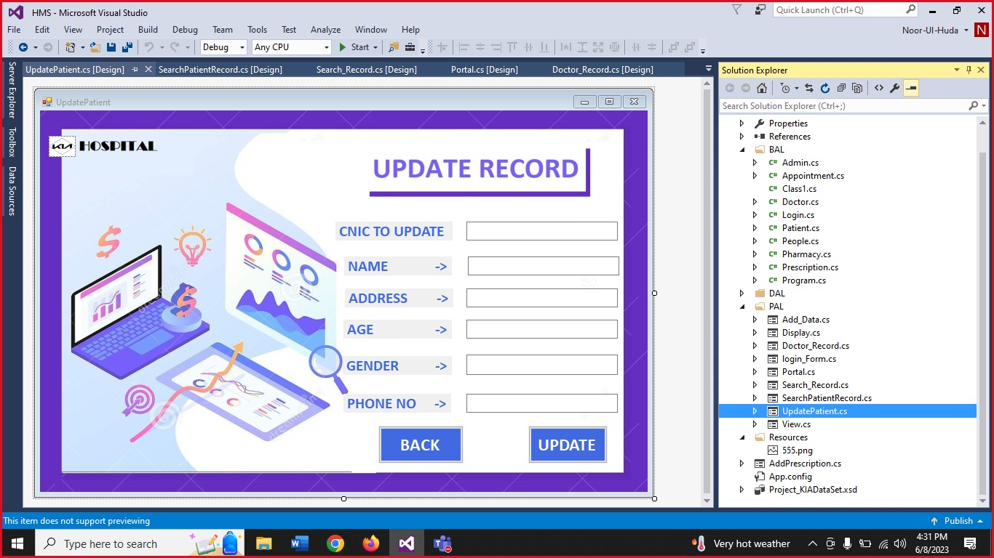

**DOCTOR RECORD:**

We can check doctors record in hospital.

## **IMPLEMENTATION**

We use C# language because C++ is very obsolete language, and the system is very older and visual studio tool. C# give us user interface in which user and admin easily interact with system and perform their activities. The libraries visual studio add it by itself when we make a class like:

* System
* System.Collections.Generic
* System.Linq
* System.Text
* System.Threading.Tasks
* System.Data
* System.Data.SqlClient
* System.Windows.Forms

The code is present in the Target System folder with name HMS.